Title (Calibri, Bold, 14 pt.) Instructions for Abstract Submission

Author name¹, Author name², … Author name^{n} (Calibri, 12 pt.)

¹Author’s affiliation and full address (Calibri, Italic, 10 pt.)
²Author’s affiliation and full address (Calibri, Italic, 10 pt.)
^{n}Author’s affiliation and full address (Calibri, Italic, 10 pt.)

Tel.: +XX (X) X XXXX XXXX E-mail: name@cnea.gov.aur (Calibri, Italic, 10 pt.)

The Scientific Programme Committee welcomes the submission of abstracts for presentation at the 9th International Topical Meeting on Neutron Radiography.
The abstract submission is independent of the registration. However, the presenting author must be formally registered at the conference at latest by September 9, 2022 in order for the abstract to be included into the final programme and book of abstracts. There must be at least one registered participant for every abstract submitted. All registered participants can be non-presenting co-authors on an unlimited number of abstracts.
The abstract should be a concise summary of your presentation. Try to avoid using scientific or engineering symbols, acronyms and bullets. It should be typed single-spaced in 12 point type Calibri. It must be shorter than 250 words and must not include references. It can include a figure with a caption, as shown below. The abstract must not exceed 1 page in A4 page format. Please place the figure at the bottom of the body text.
Abstracts must be submitted as Microsoft Word documents (*.doc, *.docx) ONLY through the submission system within the ITMNR-9 website. The name of the file should follow this example: presenter’sName_presentationType.docx
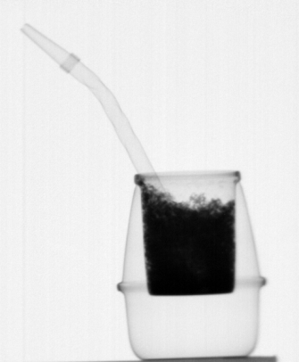
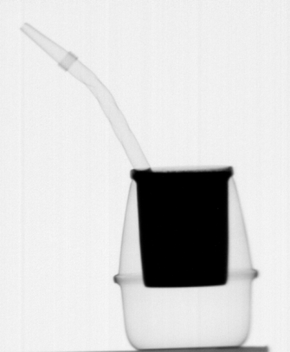
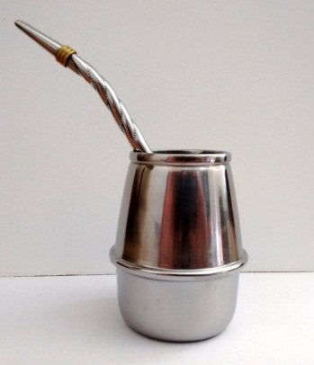
Neutron images of a “mate”, a traditional Argentine infused drink prepared by steeping dried leaves of yerba in hot water and served with a metal straw. Images were taken at the imaging beamline of the RA-6 reactor in Bariloche, Argentina. Caption font: Calibri size 11.
Top margin: 4cm
Side margins: 2.5cm
Bottom margin: 2.5cm

